CLIENT SERVER APPLICATION WITHC#.NET(WORK-LOG)

**INSTALLING SOFTWARE :**

**Time duration:-1:30 hours**

* Firstly, I have downloaded latest version of visual studio 2019, using link <https://visualstudio.microsoft.com/downloads/>
* **Right click** on the downloaded file **and run as administrator** to begin **installation**.
* It asked for **permission** to continue. **Click** on **Yes** to continue with the installation.
* After accepting the **software License terms and Privacy** Statement**. Click** on **continue** to go ahead with the installation.
* After the above step Installer fetches the **required files** to install the Visual Studio 2017.  This process will take **few minutes.**
* The Installer asked for the **features** which we want to install.  I have chosen **.NET Desktop development.**
* After completion of all the above steps, the installation got started depending upon my internet speed it approximately took one-and-half-hour.
* Once the installation is completed, there presented with the **Installation succeeded** message.
* Now the **visual studio** is ready to use.

**PREPARATION PROCESS:**

**Time duration:-3 hours**

* With the help of the resources provided by the officials from ALGOJI ENTERPRISES, I have learnt about visual studio and also came to know about the creation of forms.
* Firstly, I came across the forms and learned about the tools required for the creating the forms.
* Then learnt about the Hercules_3-2-8.extension.
* Then coming to the coding part firstly, learnt about the code for the button and then the port, mostly I took time for the socket programming, which helps in the establishing the connection between client server.
* Next came to learned about threading.
* Mostly, focused on creating the Objects, collections and generics which plays important part in the programming.
* Then, after finishing the coding part now learned about the establishing the connection, with client server.
* While working on the programming part, I came across many errors, but finally I worked on them and successfully resolved those errors.

**CREATING A PROJECT**

In order to create the project, in visual studio :

* Click on **new project** and give **name** to the project and go on.
* Next window shows the all the frame works available in the studio which depends on the option selected while installation.
* Click on Windows Form App(.net framework) which helps in creating the application with a windows forms user interface.
* Now the main window in the visual studio will be launching, with the name form1 where we need to create the forms using the available tools.

**WHAT IS WINDOWS FORMS(.NET FRAMEWORK):**

**Windows Forms**  is a free and open source graphical (GUI) class library  included as a part of Microsoft .net framework , providing a platform to write rich client applications for desktop, laptop, and tablet PC .

**CREATING CLIENT FORM:**

**Time duration: 30 minutes.**

**LABEL:**

* Label is the area where we can give **name** to the TextBox.
* According to the project allotted to me, firstly I need to create the client form.
* Search **Label** in the search **ToolBox** and double click on it.
* As Soon As you double click the label will be seen on the form. Give a single click and edit the name of the label in the **properties.**
* Name the Label as **IP ADDRESS**.
* Create the another label with name **PORT** .

**BUTTON:**

* Now search the button in the **ToolBox** and double click on it.
* The button will be seen on the form, rename the button in the properties as **CONNECT.**
* Create other button named **SEND.**

**TEXTAREA:**

* **TextArea** is the area where we enter the data which we want to send to the server and also the data received from server will be seen.
* Double click on the TextArea, so that it will be seen on the form.
* Add the label above the TextArea and give the name as our choice.
* Create two TextArea’s one to **send** the data and another to **receive** the data from the **server**.

**TEXTBOX**:

* TextBox is the area where we enter the IP address and PORT
* Search textbox and double click, as it will be seen on the form.
* Create two textbox one for each.

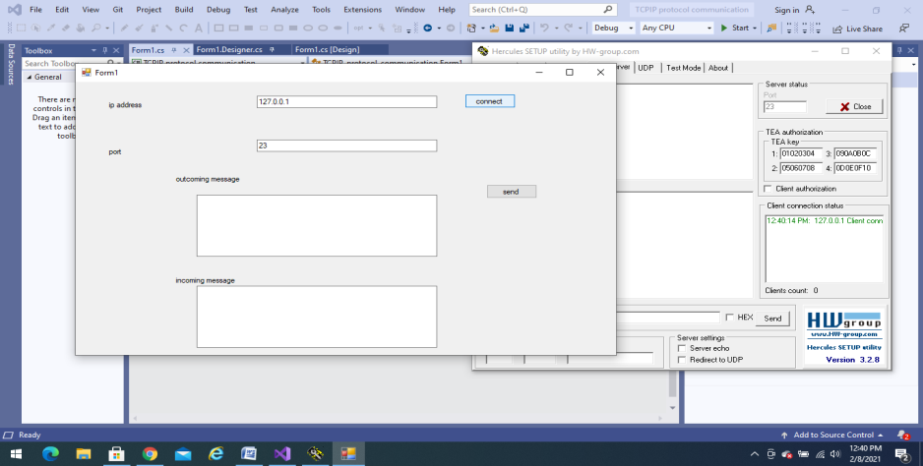

**SERVER FORM:**

* Same tools are used to create the server form, so here I didn’t created the server form instead I used the Hercules_3-2-8.extension.

**WHAT IS HERCULES_3-2-8.exe:**

Hercules SETUP utility is useful serial port terminal, UDP/IP terminal and TCP/IP Client Server terminal. It is used to connect the client or the server connection in order to establish communication and the connection is virtual.

* Here instead of creating the server form I used this extension to establish the communication.

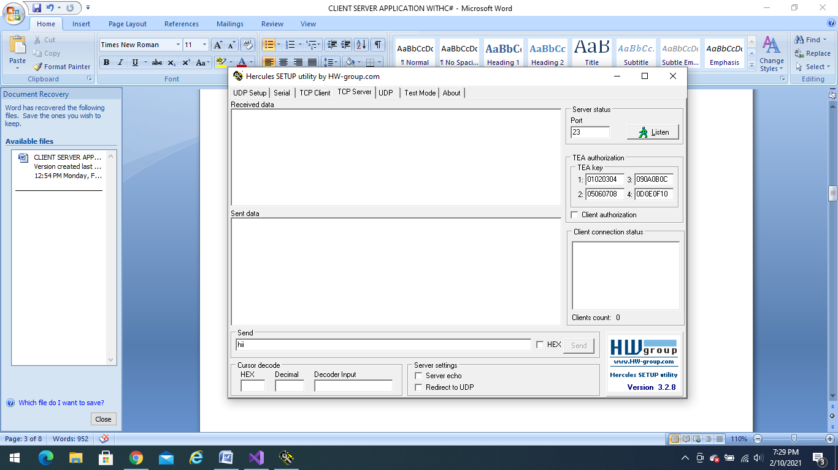

* As we are using this instead of server form choose the **TCP** **SERVER** and before establishing the connection we need to click on **LISTEN**.

As the above steps is the basics for creating forms this doesn’t took much time, but dealing with the Hercules_3-2-8.extension took time for me as this is new for me to deal with this extension.

**PROGRAMMING:**

**Time duration:- 3 hours.**

* We need to write the program for each button describing how, the button should work.
* I have faced many problems while writing the program as am a beginner, which took me more time.
* For writing the code double click on the box for which you want to write the code.
* Here firstly, I learned the basics on socket programming, then started to write the code.

CODE:

using System;

using System.Collections.Generic;

using System.ComponentModel;

using System.Data;

using System.Drawing;

using System.Linq;

using System.Text;

using System.Threading.Tasks;

using System.Windows.Forms;

using System.Net.Sockets;

using System.Threading;

namespace TCPIP_protocol_communication

{

public partial class Form1 : Form

{

TcpClient clientsocket = new TcpClient();

NetworkStream serverStream = default(NetworkStream);

string readdata = null;

public Form1()

{

InitializeComponent();

}

private void button1_Click(object sender, EventArgs e)

{

clientsocket.Connect(textBox1.Text, Int32.Parse(textBox2.Text));

Thread ctThread = new Thread(getMessage);

ctThread.Start();

}

private void getMessage()

{

string returndata;

while (true)

{

serverStream = clientsocket.GetStream();

var buffsize = clientsocket.ReceiveBufferSize;

byte[] instream = new byte[buffsize];

serverStream.Read(instream, 0, buffsize);

returndata = System.Text.Encoding.ASCII.GetString(instream);

readdata = returndata;

msg();

}

}

private void msg()

{

if(this.InvokeRequired)

{

this.Invoke(new MethodInvoker(msg));

}

else

{

textBox4.Text = readdata;

}

}

private void button2_Click(object sender, EventArgs e)

{

byte[] outstream = Encoding.ASCII.GetBytes(textBox3.Text);

serverStream.Write(outstream, 0, outstream.Length);

serverStream.Flush();

}

private void textBox3_TextChanged(object sender, EventArgs e)

{

}

private void textBox1_TextChanged(object sender, EventArgs e)

{

}

}

}

* As soon as you complete the code and debug using START DEBUGGING option and click on START .
* Now, the form you created will be seen.

**CONNECTION ESTABLISHING:**

* Now It’s time for the establishing the connection.
* Enter the IP address as 127.0.0.1 and give port address which is resembling in the server in the Hercules_3-2-8.extension i.e.,23.
* Now lets begin the connection:

1. Before starting the connection click on LISTEN button in the server side, to take the connection.
2. Now, after entering the IP address and port click on **CONNECT** button.
3. Lets check on the server side whether the connection is established or not.

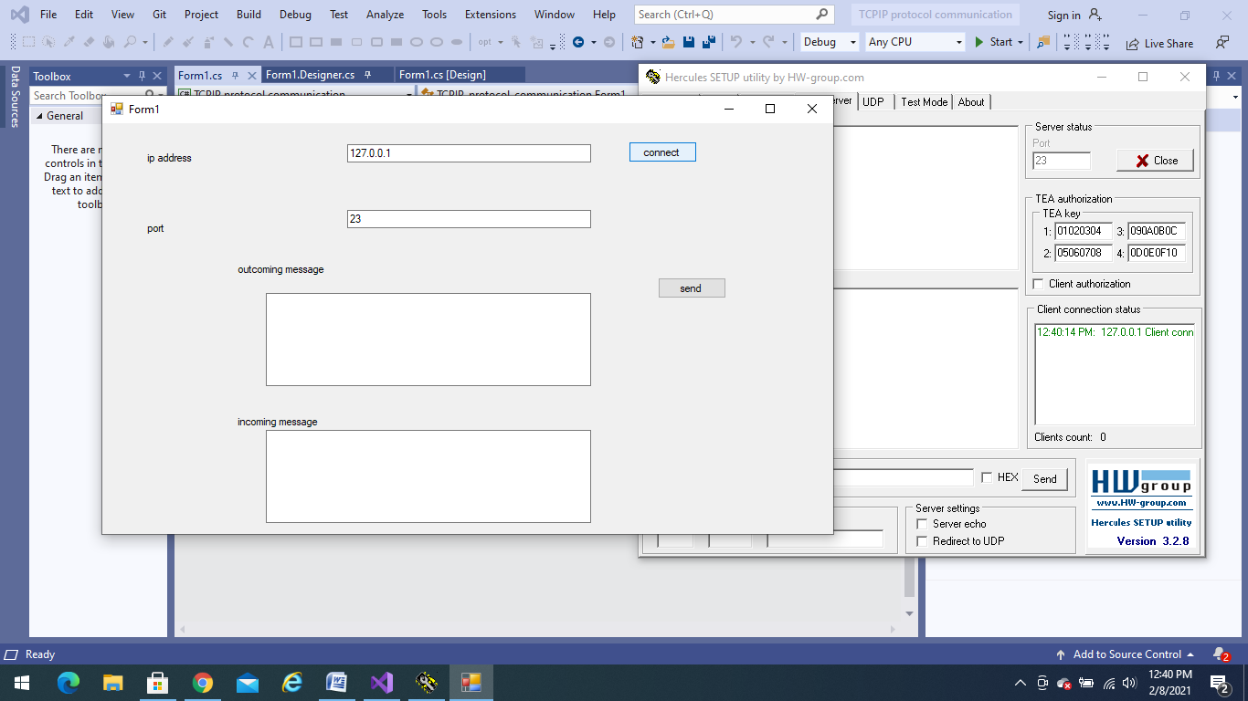 Yes, the connection is **established** now.

**COMMUNICATION:**

* Now, lets check whether the communication is established or not.
* Enter the message you want to send to client from server in **SEND DATA** click enter, the message be seen in **incoming message**.

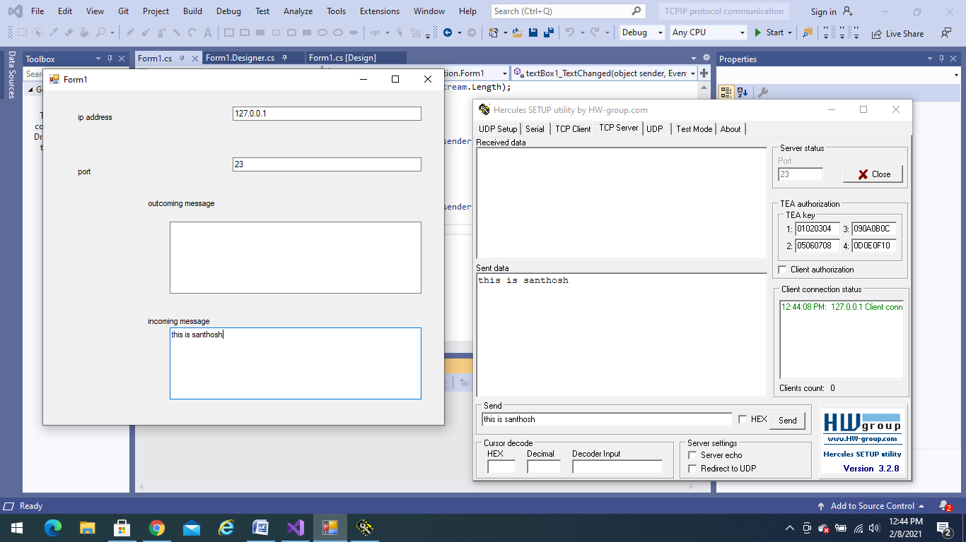

* Now, lets check for receiving data, enter the message in the **outgoing** textarea and click on **send** button the message will be resembling on the server side.

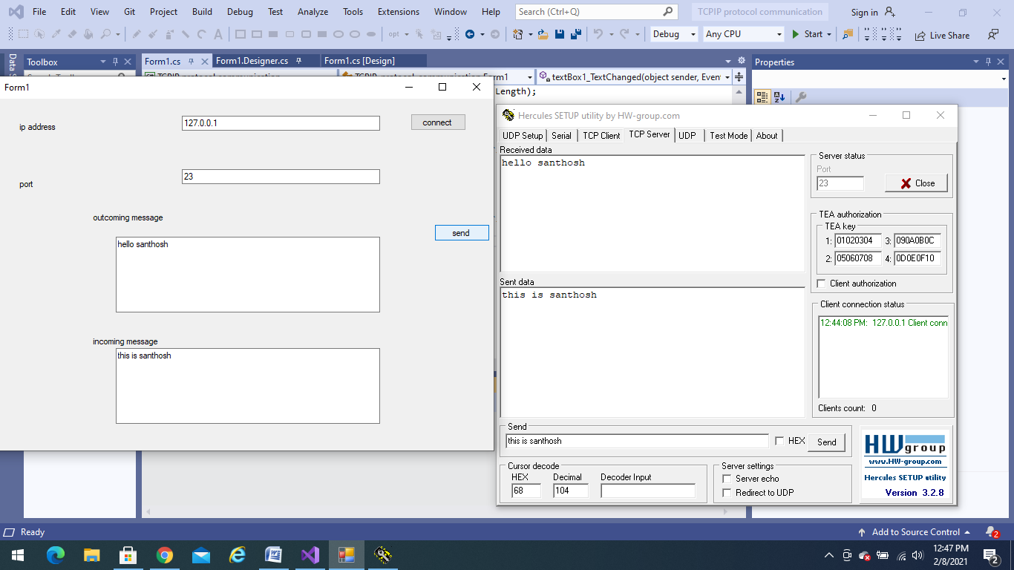

* Therefore, now the communication is established between TCP/IP client server.

**LEARNING OUTCOMES:**

* While performing this task I came across many new processes like installation of visual studio, difference between TCP/IP and UDP, creation of forms, how to establish the communication between the client server and also about Hercules extension.

**SOCKET PROGRAMING:**

It is used to connect the client server using node IP address or port address. It is used to create a secure channel of communication and use this channel to transfer data. **Socket** client and server communication. In **socket** communication, one node acts as a listener and other node acts as a client.

* Difference between TCP/IP and UDP:

**Transmission Control Protocol (TCP):**

In terms of the OSI model, TCP is a transport-layer protocol. It provides a reliable virtual-circuit connection between applications; that is, a connection is established before data transmission begins. Data is sent without errors or duplication and is received in the same order as it is sent. No boundaries are imposed on the data; TCP treats the data as a stream of bytes.

**User Datagram Protocol (UDP):**

UDP is also a transport-layer protocol and is an alternative to TCP. It provides an unreliable datagram connection between applications. Data is transmitted link by link; there is no end-to-end connection. The service provides no guarantees. Data can be lost or duplicated, and datagrams can arrive out of order.

**Internet Protocol (IP):**

In terms of the OSI model, IP is a network-layer protocol. It provides a datagram service between applications, supporting both TCP and UDP.

